1. Application overview

The below windows will appears when you start application:

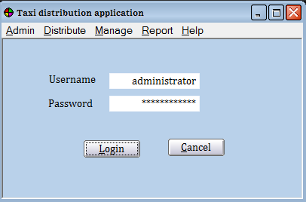

In this case, the admin login. Before logging in successfully, the user cannot use some menus in Menu bar such as Admin, Distribute, Manage, and Report. The user can use Help menu to see more detail.

After logging in successfully, the user can use all menus in Menu bar. The following

figures are some screenshots of application:

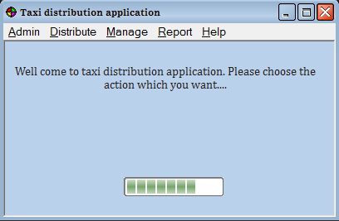

1. User login

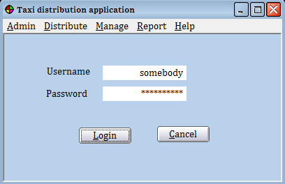

When an user login successful, the Admin menu will be disappear:

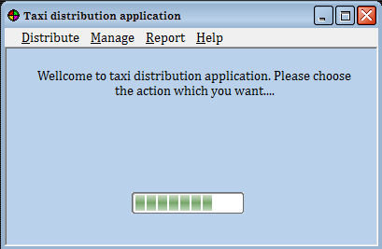

1. Admin menu

He use the menu Admin to create new user or delete an existing user.

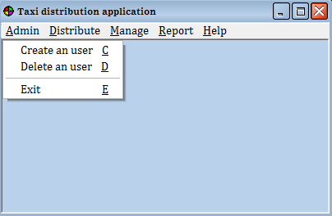

When administrator choose the “Create an user”, the below screen will be display:

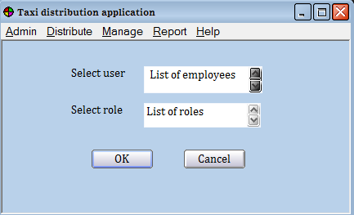

List of employees: contain the full name of all employees in the office.

List of roles: include all of roles which access the application: taxi distributor, taxi distribution report, taxi driver management.

And this is a screenshot when administrator choose the “Delete an user”:

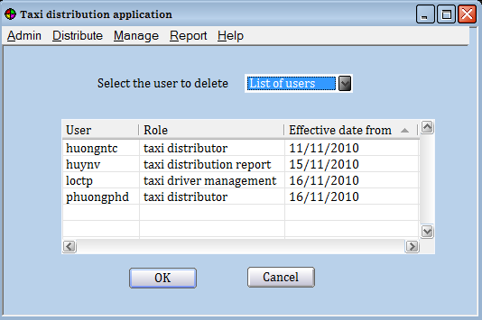

If user click OK whom don’t select the user at combobox, the system will be show the message:

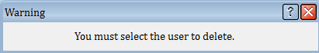

Otherwise, the message box will be display:

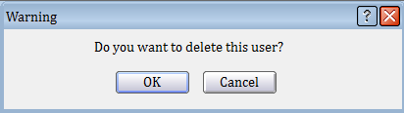

1. Distribute menu:

In this below picture is distribution screen after user select Distribute:

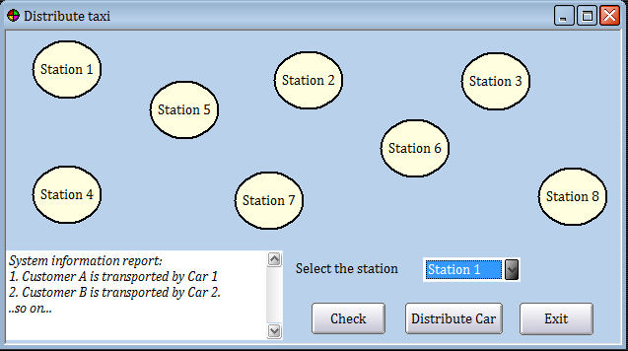

When user select station and click check, the screen will be as follow:

1. dfdf